===================================================================
SELENIUM AUTOMATION FRAMEWORK - SETUP & CONFIGURATION
===================================================================

📌 PROJECT OVERVIEW
--------------------
This project is a Selenium-based UI test automation framework built using:
- Java
- Selenium WebDriver 4.33.0
- Maven (Build Tool)
- TestNG (Test Framework)
- Chrome Browser
- WebDriverManager (Driver Management)
- ExtentReports (Reporting Tool)
- [Logging Tool: Pending Integration]
...

Prerequisites to be installed in machine before importing framework
- Java 11 above version
- Eclipse IDE
- TestNG
- Chrome Browser latest version
- Maven latest version
Once framework archive folder downloaded, please follow the below steps

1.Open Eclipse
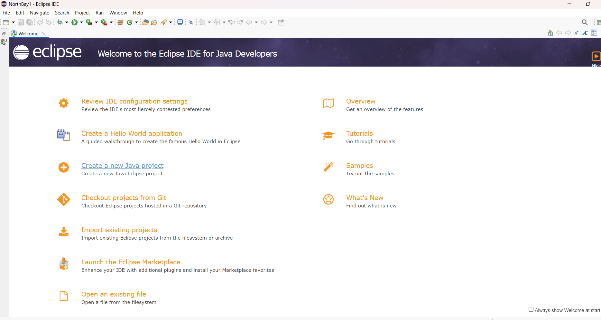
2.Select File>>Import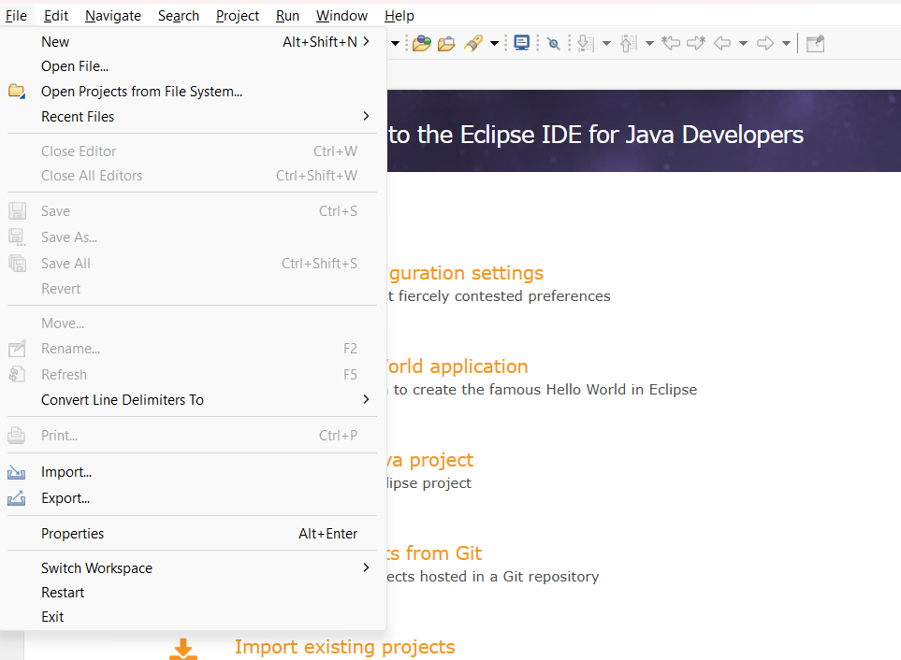

3. Select General>> Existing projects into Workspace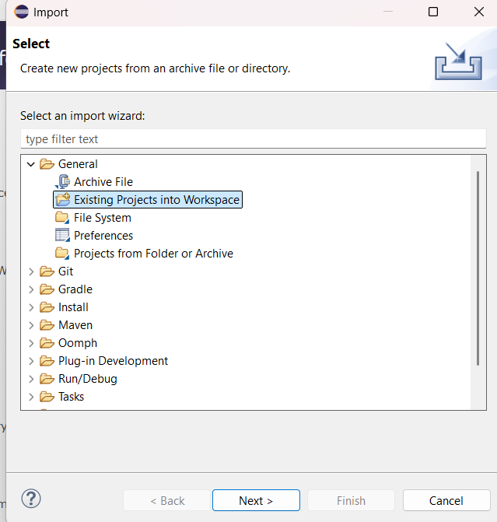

4. select archive file which is attached in mail and click on finish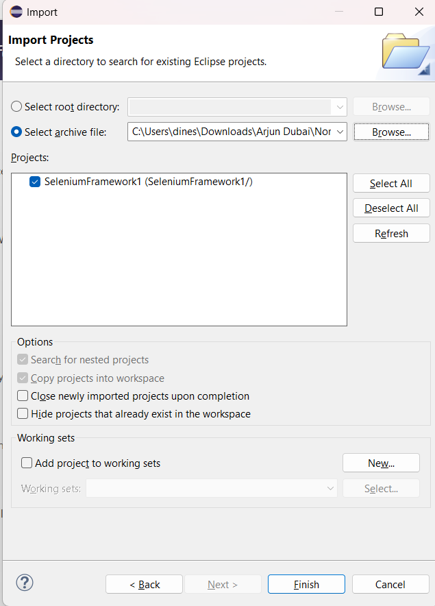

Wait until all project is build automatically and dependencies are added to project without errors
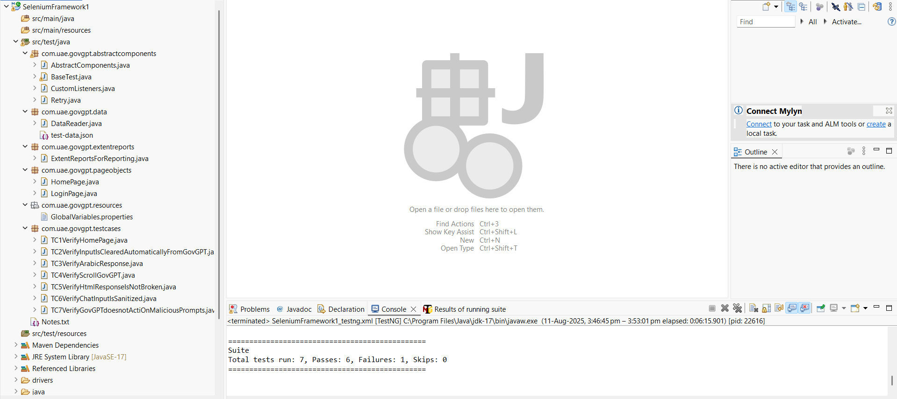

▶ HOW TO RUN TESTS
-------------------

Using IDE:
- Right-click on the test class or testng.xml file to run all testcases→ Run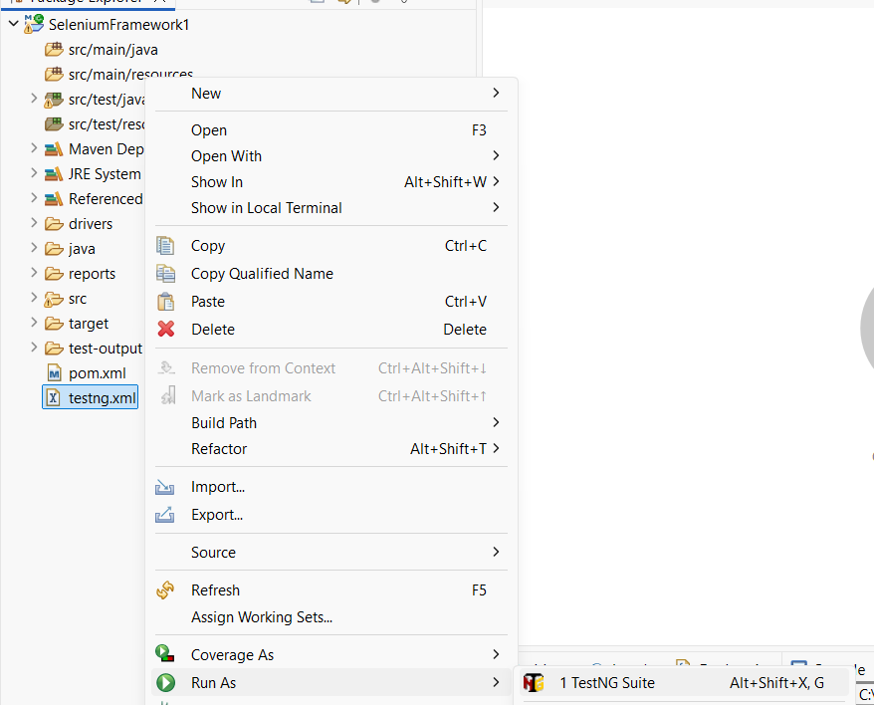

Using terminal:
$ mvn clean test

...

📊 VIEW TEST REPORTS
---------------------
- After execution, open: `reports`>>index.htm under
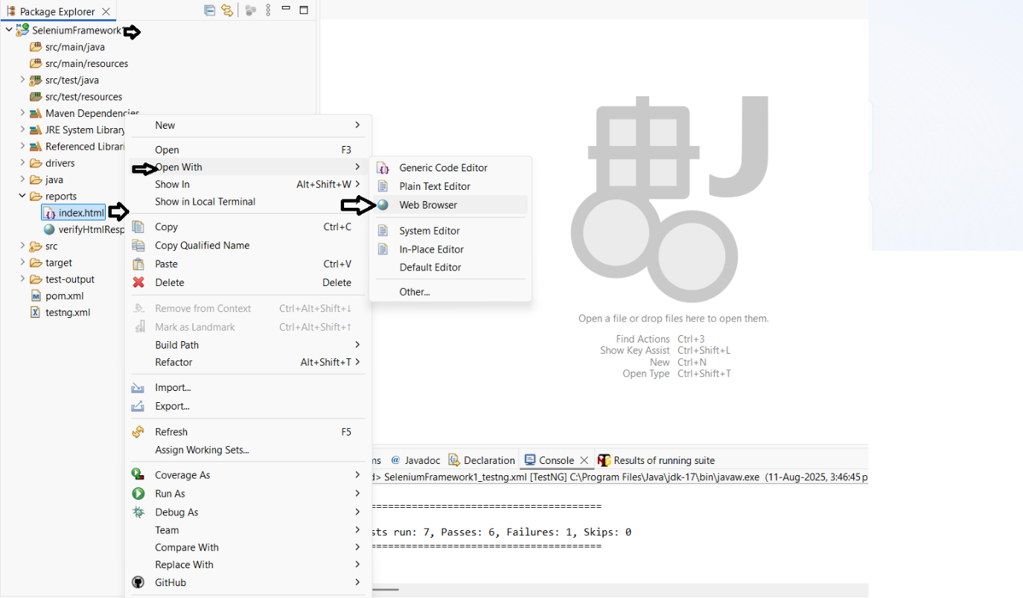
- View results and logs in a browser.
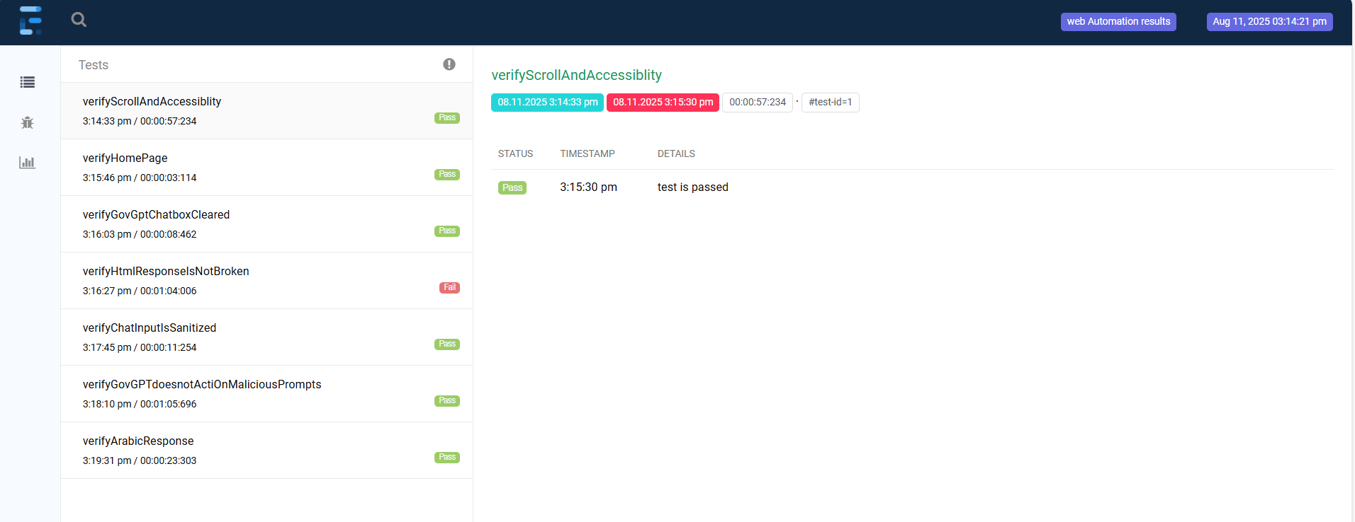
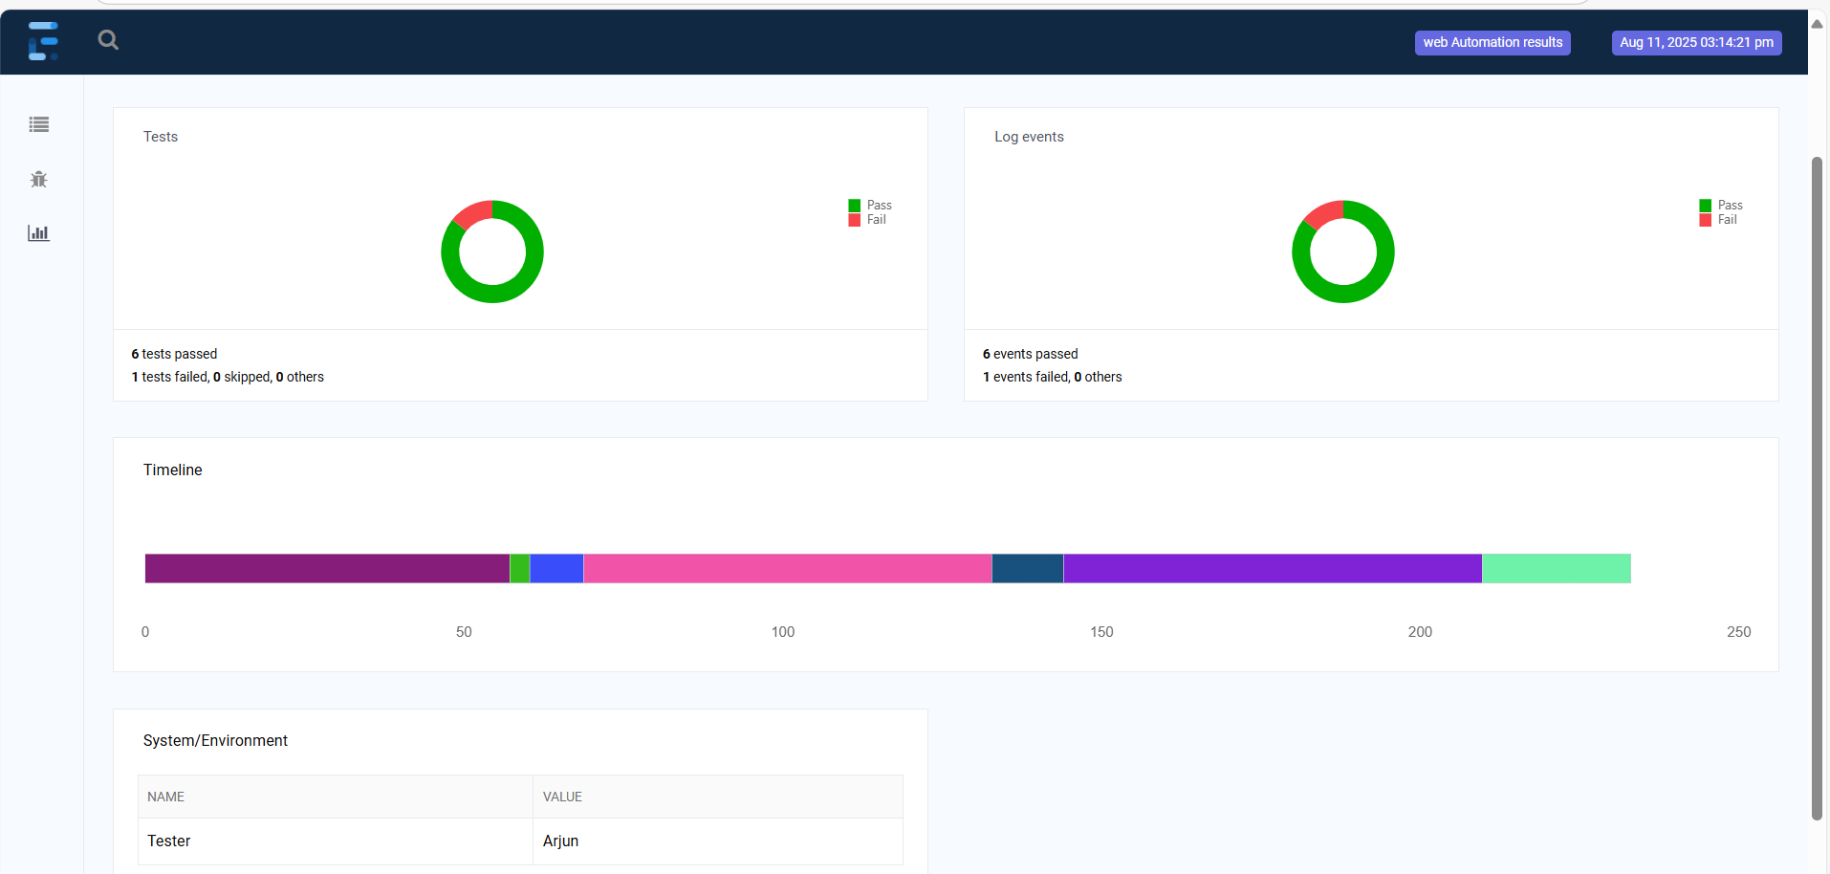
...

🧪 NOTES
---------
- Logging (e.g., using Log4j or SLF4J) is planned but not implemented yet.
- Consider integrating with CI/CD tools like Jenkins for continuous testing.
- Future improvements: Docker support, parallel execution, grid configuration.

